CHAPTER VI

The Invention of Wireless

Introduction

My grandparents would sit around the wireless – by which they meant the radio. But these days we think of wireless differently, and we call it WiFi. But what an extraordinary development it has turned out to be.

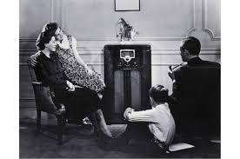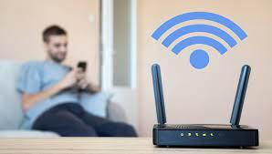

Fig. 6.1. The “wireless”, then and now!

The invention of wireless, like nearly all advances, was not the result of a single invention, but a combination of work by many scientists and engineers, often working independently. As a result, there were continuous battles and sulks over priority, which were compounded by the aggressive use of patents and the large amounts of money to be made from them. As usual, the physical understanding of the new technology lagged well behind its application, although it followed directly from Maxwell’s prediction of electromagnetic waves and Hertz’s demonstration of their existence. Perhaps the only further use of the theory was the obvious result that radio waves propagate in straight lines, so that it would be quite impossible to transmit across the Atlantic Ocean.

So, let’s take a look at this incredible story.

One of the most remarkable features is that the first inventors were operating at frequencies and detectors that were not used again until the second world war. Hertz used a frequency of about 0.2 GHz (and hence a wavelength of 19 cm), whereas J. C. Bose used a Shottky diode to detect waves in the millimetre range to set-off a bell and initiate a gunpowder explosion. This was possible because they were operating in a different voltage and current regime from valves and transistors. Modern wireless technology uses volts and milliamps, but their source of volts was a 20 kV induction coil and currents of the order of nanoamps. In this regime a Leyden jar, despite its tiny capacitance, was a useful energy storage device. Nevertheless, it still seems extraordinary that Marconi, using a two-inch spark in England, could produce a microweld in copper filings across the Atlantic Ocean in America. Quite apart from the energy transmission required, this raised questions about the numerous lightning strikes in the US with a power millions of times greater than Marconi’s sparks, and much closer that did not produce similar effects.

The regime of kilovolts was reduced to many volts on the invention of the diode valve by Fleming and the later development of the triode by de Forest. There is little doubt that the triode valve is the most important invention of the twentieth century, since for the first time (apart from a few specialist devices), it produced power amplification and hence was the precursor to the electronic age. Transistors and microcircuits made it more reliable, smaller and cheaper, but they are nevertheless just improvements on de Forest’s amplion. However, he had no idea of the enormous implications of what he had achieved until six years after its introduction, since he regarded it as only a better detector. Unfortunately, the de-Forest company went bankrupt just before several engineers discovered the amplion could oscillate and produce continuous radio waves, as well as amplify incoming signals. The receivers of the company concluded that there were no significant assets apart from the rights to the amplion, which, as far as they were concerned, appeared to have no useful application. The subsequent patent battles went on for many years.

Hertz’s Demonstration of Electromagnetic Radiation

How did Hertz demonstrate radio waves in the near GHz region with such simple apparatus? The answer is that it was because the apparatus he used was very simple and consisted of an induction coil generating pulses of several kilovolts. Each one charged up the antenna, treated as a capacitor, until a spark across the spark gap shorted out the circuit, causing the spark to die as the charge dissipated and starting the process again. In fact, for this process the terms ‘capacitance’ and ‘inductance’ are pretty meaningless since they only apply to lumped circuits (or to per unit length in a transmission line). If a charged pair of good conductors is shorted, the time constant is just that to give radiation of a wavelength comparable to the size of the system. All the electrical parameters depend only on the dimensions, so if there is only one dimension, the size of the plates (the thickness of the plates is not relevant), we automatically have a system whose size is about a wavelength and therefore transmits efficiently. (The radio waves come from the complete circuit, not the spark gap. Also the inductance of the tesla coil is infinite at these frequencies and can be ignored.) On the downside, for the same reason, the radiation resistance is going to be comparable to the imaginary parts of the impedance, with the result that the waves could be either side of critical damping. Fortunately for Hertz they were periodic, but with only a few cycles before being damped out. (The radiation resistance at resonance is about that of free space, 75 ohms, and is much larger than the ohmic resistance of the circuit.) He was therefore able not only to demonstrate that the waves could be reflected and focused by conducting sheets, but also to demonstrate interference and hence measure the wavelength. In later experiments Hertz added separate capacitance and inductance, which allowed him to calculate the frequency and show that the velocity was that of light.

The receiver was a single loop of wire with a very narrow spark gap, but since it was a similar size to the transmitter, and hence the wavelength, it was also well matched to the incoming radiation. Thus, while subsequent experimenters had to spend a great deal of effort in matching frequencies and impedances with more complex structures to achieve longer transmission distances, the Hertz system achieved this without effort, although only over a distance of a few metres.
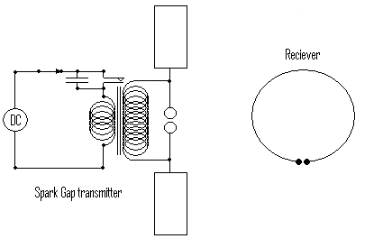
Fig. 6.2. Hertz’s Apparatus.

It is still a bit surprising that Hertz could generate enough volts to cause a spark from a one turn coil. Even for a gap of 10 microns, which was the rough value of the gap, about thirty volts would be needed. However, since the transmitter used many kilovolts, perhaps thirty volts at a metre away is not too improbable. (The largest induction coil made by Apps in 1877 made a 42-inch spark which required a 1.2 MV source.)

A more fundamental issue is whether the spark in the receiver was just due to an inductive voltage, which Faraday could have explained without Maxwell. In fact, Hughes had performed a similar experiment much earlier and this was explained as induction. The ratio of the inductive field at a distance r to the radiative field is 2πr/λ, where λ is the wavelength. This was again of the order of unity, so the inductive effect could not be excluded on the grounds of distance alone. It was the reflection and interference that proved the existence of waves.

Oliver Lodge, Bose, Fleming, Marconi and Tesla (and others!)

Hertz’s results were taken up and improved by numerous physicists including Rutherford, Popov, Tesla and Bose although the resulting intellectual ownership battles were typified by the relations between Lodge, Fleming and Marconi. Lodge was an academic physicist who demonstrated transmission of waves in the laboratory, and further, as a laboratory phenomenon. Marconi was an engineering entrepreneur who demonstrated longer and longer transmission distances with a secret ‘black box’ and patented everything connected with wireless telegraphy to the rage of all the others. Tesla patented many of the techniques before Marconi to the extent that in 1935 the US Supreme Court revoked the Marconi patents and awarded them to Tesla.

Fleming was a highly respected electrical engineer and Fellow of the Royal Society who contributed a huge amount to the spectacular success of Marconi in transmitting across the Atlantic. He also invented the first thermionic diode but felt his work was not sufficiently appreciated by Marconi.

However, as well as being a successful businessman Marconi was clearly an engineering genius in making things work without having much theoretical understanding. Much of the quarrelling over priority was on the definition of ‘wireless telegraphy’, which is what the money was made from, and mainly from ships since land wires were satisfactory and relatively secure. Lodge thought he had invented wireless telegraphy by sending pulses, ‘on and off’ in the laboratory. Marconi made and sold systems that could be used to transmit useful messages from ship to shore and ship to ship, and, most famously, between the sinking Titanic and its rather late rescuer the Carpathia. An excellent account is given in the book by Sungook Kong (1) from which much material has been drawn for this chapter.

Marconi

There is no doubt that the man who created practical wireless telegraphy was Marconi. He did this by numerous detailed inventions and attention to detail in making the circuits work. In this he was greatly indebted to Fleming, the electrical engineer. To transmit across the Atlantic, Marconi needed a two-inch spark, so Fleming replaced the small batteries and spark coil with a 25 kilowatt generator, a high voltage transformer and a cascade of increasing voltages and frequencies. While this might seem a small improvement to a physicist like Lodge, any electrical engineer will tell you it is far from trivial. Marconi’s contribution was improvements in the electronics. One was to put a capacitor and inductor in the spark circuit and couple it loosely to the antenna with a mutual inductance which he called a ‘jigger’. This reduced the frequency and increased the Q of the circuit so that many periods of the wave were transmitted with each spark. It not only increased the transmission distance but allowed messages to be separated in frequency and be more secure.

Security of the messages and interference were concerns that were not significant in cable telegraphy but could clearly be a problem with wireless technology. An attempted demonstration by Fleming led to the first, and most amusing, incident of hacking, known as the Maskelyne Affair. In 1904 Fleming was about to deliver a lecture in the Royal Institution that would demonstrate that Marconi’s tuned circuits would eliminate the interference problem when, to the operator’s horror, the printer began printing out ‘rats rats’ and the following lines.
‘There was a young fellow of Italy
Who diddled the public most prettily

The remainder of the verse seems to be lost, perhaps deliberately.

Fleming was outraged, describing the attack as ‘scientific hooliganism’. He thought that the author, an opponent of Marconi called Maskelyne, had done it from very close range by using large earth currents, but in fact he had used a heavily damped non-resonant spark transmitter that included a sufficient range of wavelengths to operate Marconi’s tuned system. The technology was revolutionised in the next few years by the invention of the thermionic valve.

However, even with the relatively insensitive ‘coherer’, Marconi was able to transmit a message across the Atlantic. The coherer was a tube of loosely compressed metallic particles. Initially a thin oxide layer caused a fairly high resistance between the particles. This oxide resistance decreases rapidly with temperature. Above a certain voltage enough current passed at an interface to heat it up until a local thermal runaway occurred and metal contact was made, reducing greatly the resistance. It may sound incredible that a spark in England could weld metals in New York and merits a more detailed look at the numbers.

The transmitter used 25 kW radiating in a circle between the ionosphere at 80 km height and the earth. This means there was 1.4x10⁻⁸ watts m⁻² at the receiver located 3500 km away. The electric field in a wave of this power is 3.3 mV/m so that a 300 m aerial could produce an emf of about a volt. This is sufficient to work a coherer so we can understand how Marconi’s achievement was at least possible theoretically.

The Thermionic Valve

The history of the thermionic valve is equally controversial and complex and begins with the ‘Edison Effect’. Edison noted a curious shadow of the filament on the surface of his carbon filament bulbs. What was seen was that the carbon tended to deposit on the surface of the bulb, but there was a clear section above the positive part of the filament. In the Crookes effect observed in discharge tubes, it was observed that negatively charged ions emanated from the cathode and it was assumed that in the bulb these carbon ions emitted at the negative end were attracted to the positive part of the filament and did not reach the glass, creating a clear line. Edison inserted a shield between the filament and glass to reduce the blackening, but then measured the current flowing to this electrode. He found a marked difference in current according to whether the electrode was connected to the positive or negative terminal of the filament. He connected a galvanometer in series with the electrode and patented it as a ‘regulator’ for monitoring the filament current. He had in fact made the first thermionic diode although at that point it would not have been very useful.

Two years later J. J. Thomson ‘discovered the electron’, and ten years later Richardson published his equation on thermionic emission (although initially this was not connected with Thomson’s electron). Thomson’s Cathode rays were generated in cold cathode vacuum tubes by the ionisation of low-pressure gas and all the work on thermionic valves was interpreted as the action of ions in the residual gas or sometimes, and closer to the mark, ions being expelled from the cathode by the Crookes effect. In any case most engineers were not in contact with the physicists working on gas discharges, so it was not until about 1915 that the connection was made between Thomson’s electrons and the circuit current observed in valves caused by thermionic emission. The development of valves was done, if not in complete darkness, at least with only a dim theoretical understanding at the time.

It was Fleming who investigated the Edison effect in much more detail and showed that a thermionic diode made a very effective detector of radio frequency waves. It soon replaced the unreliable and insensitive coherer. At the same time de Forest was investigating the use of flames as a detector. This involved putting electrodes on either side of a gas flame, which rectified the radio frequency signal. He then had the idea that this could be made more reliable by putting a hot gas in a container instead of using a flame, with an electrode on either side of the filament. He called this the amplion. He experimented with various positions of the second electrode, some of which are illustrated in fig. 6.3, ending with that in fig. 6.3(c), which looks very much like a triode valve.
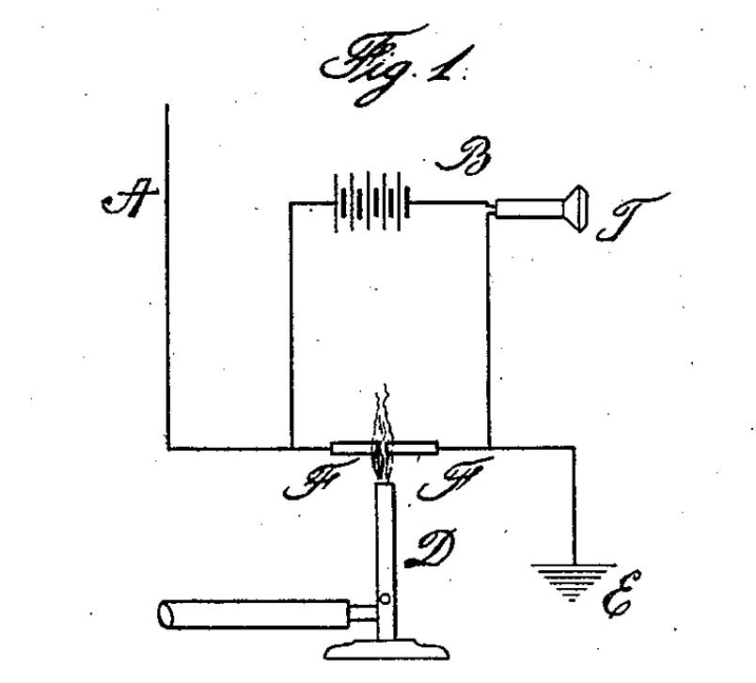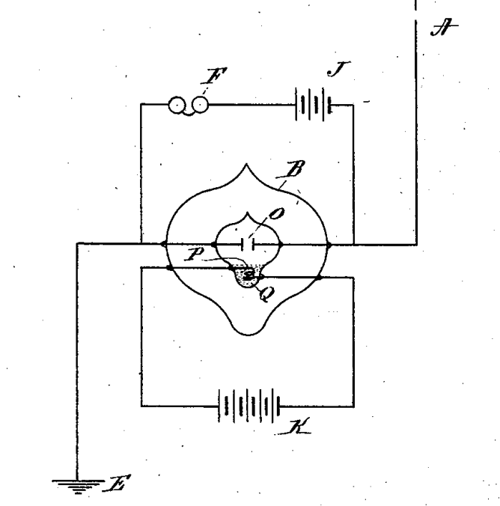
(a) a flame detector (b) The flame is replaced by a heated gas in an envelop

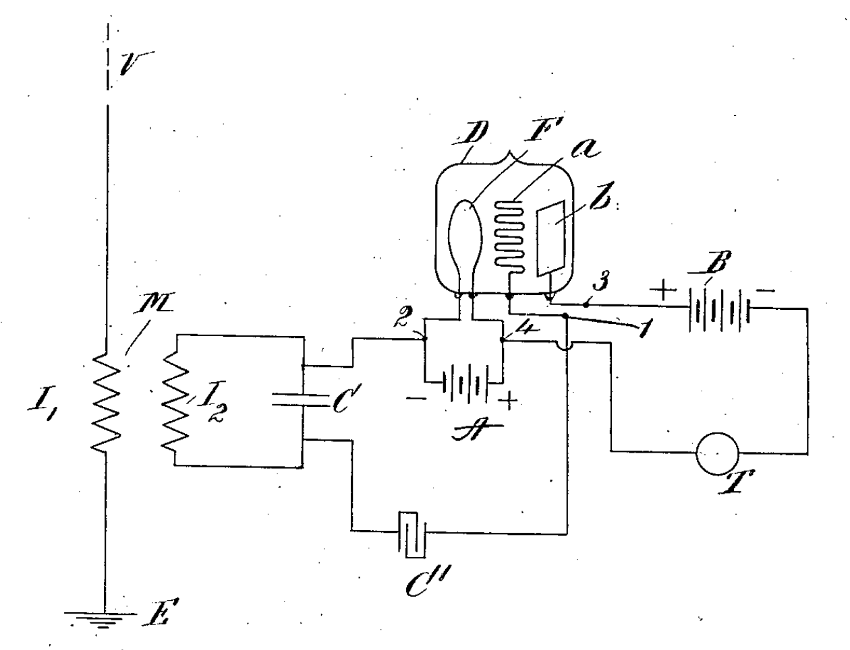
(c) The final de Forest company version before it went out of business.

Fig. 6.3. de Forest’s investigation of the use of flames as a detector.

However, de Forest’s only saw this as an improvement on the diode detector, although he did talk about the grid amplifying the effect. The amplion patent was not considered of any value when his firm went bankrupt. It is not clear how it was an improvement as a detector. Fig. 6.3(c) is essentially a triode valve, as shown in Fig. 6.4, but it is obviously a descendent of de Forest’s previous detectors with the grid in a different position. There is no negative bias on the grid, which is connected to the cathode, so it did not work as an amplifier. To get a triode to work requires the grid and anode voltages to be chosen carefully and the diameter of the grid wire is also important. The analysis is not straightforward and is set out below. However, about two years after de Forest went bankrupt, several engineers discovered the use of the amplion as an oscillator and amplifier and the electronic age was born. Thirty years later its use as a fast switch was the dawn of the computer age. The patent battles went on even longer ending only with the suicide of Armstrong, worn out by court cases against de Forest.

How the triode works

Fig. 6.4 shows a standard diagram of a triode valve.
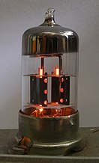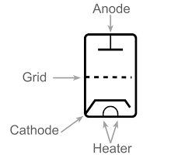

Fig. 6.4. The triode valve.

The idea is that the hot cathode expels electrons by thermal activation into a narrow layer around it, and these are then attracted to the anode by a large positive voltage. The signal voltage is applied to the grid and varies the electric field at the cathode so varying the current reaching the anode. Gaps in the grid allow the electrons through, and the grid has a negative bias so that it does not pick up electrons. So far so good.

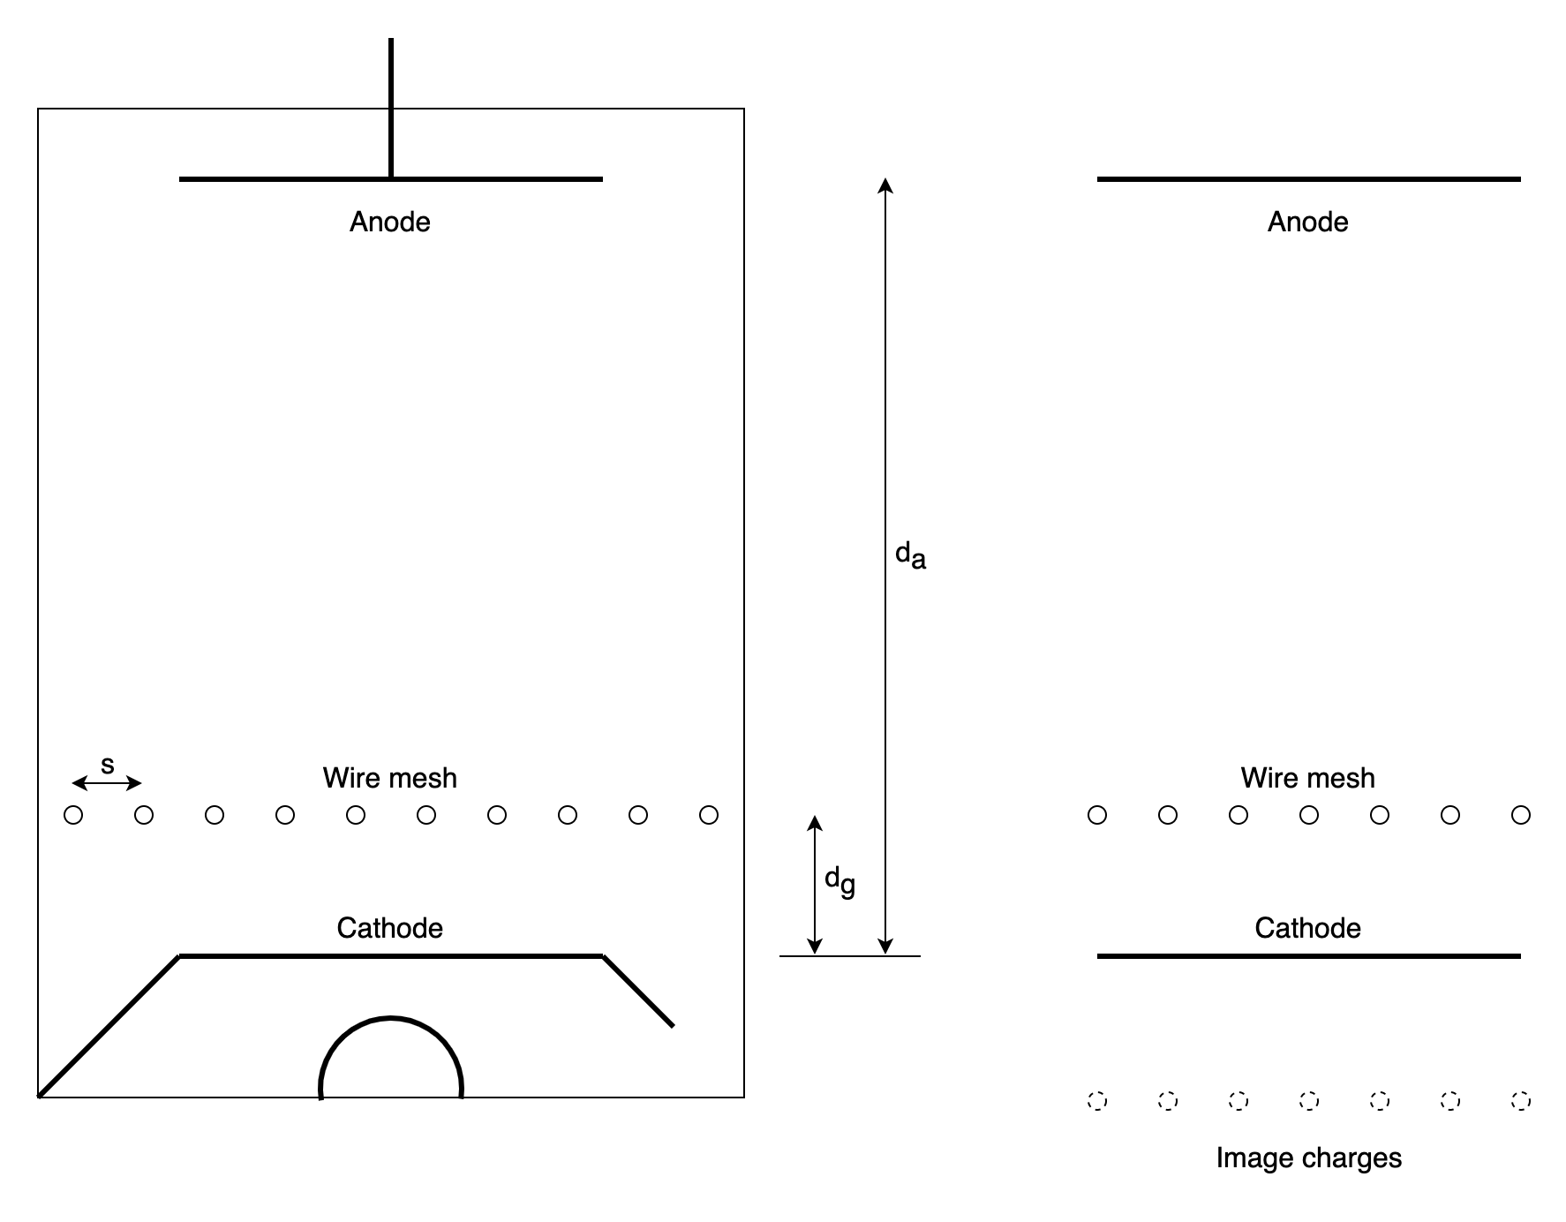
(a) | (b)

Fig. 6.5. The basic triode valve. (a) Principal components, anode, heated cathode and wire mesh. (b) Analysis using image charges.

The obvious explanation of the amplifying effect is that the grid is closer to the cathode than the anode, so we obtain a larger variation than if the signal is applied to the anode and an amplification equal to the ratio of the anode and cathode distances. This is not correct. The true explanation is more subtle, although simple electrostatics, and the amplification is nearly independent of the grid cathode distance. Fig 6.5 shows a diagram of a triode with fine grid wires rather close to the cathode. q_{a} and q_{g} are the charges per unit length on the anode and grid respectively. d_{a} and d_{g} are the distances from cathode to anode and grid. If the construction were cylindrical, with the anode the outer cylinder, then earthing the anode would mean that the valve is always electrically neutral, since there is no electric field between the anode and a distant earth. Therefore, there must be a charge –(q_{a}+q_{g}) on the cathode. This determines the electric field at the cathode, and hence the emitted current. Earthing the cathode instead will only add a very small charge to the valve and has no effect on its operation, so it is reasonable to assume the cathode is at zero potential. (A complete solution would add a very small capacitance between each electrode and a distant earth.)

Isolating the grid and adding q_{a} per unit length to the anode creates an electric field q_{a}/ε_{o} at the cathode and raises the potential of the anode to q_{a}d_{a}/ε_{o.} It also raises the potential of the grid by q_{a}d_{g}/ε_{o} but we shall neglect this initially. If we instead isolate the anode and put a charge q_{g} per unit length on the grid, then the charge on each wire is q_{g}s, where s is the spacing between the grid wires. There is then an image charge in the cathode since it is an equipotential and earthed. The potential of the grid wire due to its charge and the image is sq_{g}/2πε_{ο} ln(2d_{g}/a), where a is the wire radius. (This also gives the input capacitance.) The anode potential is determined by an image charge plus an equal charge on the anode to make it neutral. This potential is also fairly small and shall also be neglected as a first approximation.

The potentials can now be added following the addition of add both charges.

The anode voltage V_{a} is:

and the grid voltage:

From Gauss’ theorem, the mean electric field at the surface of the cathode is (q_{a}+q_{g})/ε_{o}, (integrating round a surface parallel to the cathode surface just outside and just inside it).

Hence

This field determines the current, which is written as:
or

Here R_{o} includes geometrical factors and the thermally activated current from the filament, for which it is difficult to find a simple expression. R_{o} is therefore the measured resistance of the valve with an earthed grid and can be assumed constant for small oscillating signals on the grid superimposed on a DC bias. Typically, we apply 150 volts to the anode and generate 10 mA, so R_{o} is about 15 kΩ. μ is the ratio of grid to cathode influence on the current. We see that μ depends mainly on the ratio of the grid wire spacing to the anode cathode distance and only logarithmically on the cathode grid distance. For example, if d_{a}=10 mm, d_{g}=2 mm, s=6 mm and a=0.1 mm, then μ=2.8, compared with an FE calculation of 10. This rather poor agreement is due the assumption that the spacing of the grid wires is large and needs to be smaller to achieve significant amplification (although valves would still be very useful with μ<1).

The voltage on the grid due to anode charge leads to significant feedback. More accurately:

Here D is the reciprocal of the capacitance called the ‘elastance’. Kennelly suggested as associated unit of measurement of ‘darafs’, but this is not the accepted SI unit (which is ‘reciprocal farads’).

The diagonal terms are as above, and D₁₂ is d_{g}. D₂₁ is more difficult to estimate using images, but we can use the fact that D₂₁=D₁₂ since the energy of the capacitors is independent of the order in which they are charged. (This is a nice example of the reciprocity theorem which can be used in many linear systems such as mutual inductance and virtual work.)

Including the cross terms raises μ to 5, which is acceptably accurate.

A detailed analysis of valves in the book by Beck (2), which includes a description the cavity magnetron which gave the RAF the advantage over the Luftwaffe in the second world war by generating radar signals of short enough wavelength to be carried in a night fighter. A magnetron can now be found in most kitchens in the microwave oven.

Use as an Amplifier and Other Technologies

Fig 6.6 shows how the valve is used as an amplifier. Bias voltages are applied to grid and anode (in practice with networks of resistors rather than separate batteries) and a small oscillating voltage to the grid. R is the resistance in the output circuit.
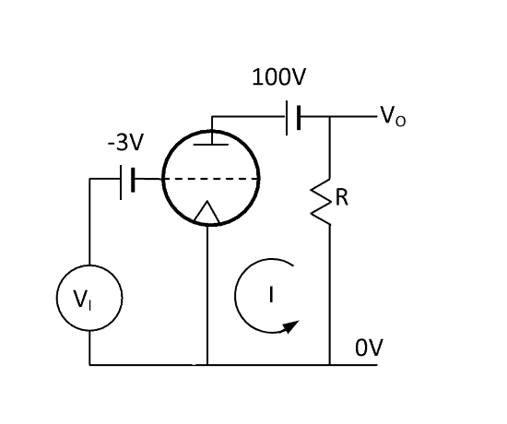
Fig 6.6. A complete triode amplifier

In the anode circuit

(of course, the electrons are flowing in the opposite direction to I)

and also
Ignoring the constant terms

Hence for a large load resistance we obtain a voltage gain of μ. This was the first application to amplify radio signals at a frequency that was too high for a transformer and had to wait until ferrites were invented before it realized its full potential.

Putting a resistor of 15 kOhms in series generates a maximum power of the order of 1.5 watts.

The input power is negligible since the only impedance is the capacitance between the grid and cathode which is about 1 MΩ at 1 MHz, so hardly any current is drawn and the power gain is about 2000.

However, this high output impedance meant that it is difficult to match the valve to a loudspeaker with a typical resistance of 5 ohms. Either an output transformer, or negative feedback by putting the speaker in series with the cathode (a cathode follower) was required.
On the other hand, it is considerably lower than the input impedance of a following triode stage so that the apparently roundabout method of combining the incoming signal with a local oscillator in a non-linear element was used to produce a s signal at the much lower difference frequency. This could be coupled more easily to subsequent stages by, for example, transformers. This was the ‘super heterodyne receiver’, used universally from an early stage.

Digital Systems

A relatively small negative voltage on the grid will turn off the current to the anode and almost no current is required. Up to this point, relays were made with solenoids and moving contacts so were limited to a few hundred Hertz. The valve raised this speed to many megahertz and allowed the construction of digital computers. However, thousands of valves are expensive, and since they had hot filaments, they failed at regular intervals. They required a large maintenance team and cost millions of pounds. It was thought about ten such computers would be the market for the UK. The invention of semiconductors and the ability to compress millions of relays onto a cheap chip is one of the most remarkable technical achievements in human history.

There are some who say that valve amplifiers give a better sound than semiconductors, but this seems highly improbable given that the harmonic distortion in both types of amplifier is well below that detectable by the human ear. (However, this is not as incredulous as those who spend a lot of money on grain aligned copper wires for loud-speaker connections).

1. Sungook Kong, Wireless, MIT Press, 2010.
2. W. Beck, Thermionic Valves

